**Debugging & Traceability**

|  |  |
| --- | --- |
| Date | 11 November 2022 |
| Team ID | PNT2022TMID41871 |
| Project Name | Real-Time River Water Quality Monitoring and Control System |
| Maximum Mark | 2marks |

# FORMATIVE STUDY

To understand the current limitations of automatic hint delivery and opportunities to

improve it, we observed the hint giving practices of teachers in a local introductory CS course as they helped students debug incorrect code for programming assignments.

We analyzed 132 Q&A posts from the CS course’s online discussion forum where instructors

answered students’ debugging questions. Additionally, we conducted a semi-structured interview with a teaching assistant from the same course to gain insight into the patterns of hint-giving that we observed in the online discussions. This analysis yielded three design guidelines that motivated the design of Trace

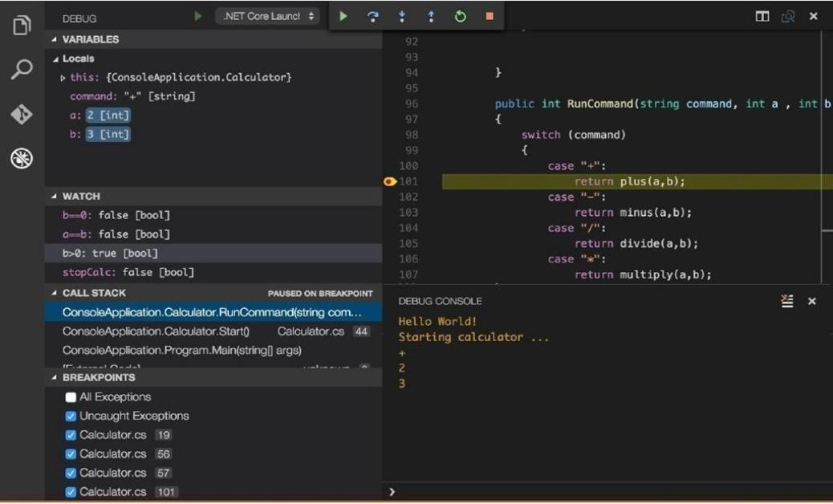

INTERFACE DESIGN:

The interface can leverage this pair of incorrect and correct programs to show the student the difference between the actual behavior of their submission and expected behavior which would pass all the test cases for the assignment.

The system executes the incorrect and fixed programs, and stores a snapshot of both their

internal states at every execution point. Using this information, the system interface, shown in Figure 2, renders execution traces of both the incorrect (D) and fixed (E) programs side-by-side. To help the student find the behavioral differences, the interface highlights where the incorrect program diverges from the fixed one

At the start of each study session, we gave each participant a 6-minute tutorial on

both Python Tutor and Trace Diff to familiarize them with each interface. We then gave each participant four incorrect submissions (two for Trace Diff and two for Python Tutor) and asked to perform two tasks for each problem: (1) point out the location of the bug and (2) fix the bug. For each incorrect submission, we explained the programming assignment to the participant and then gave them ten minutes to perform the tasks

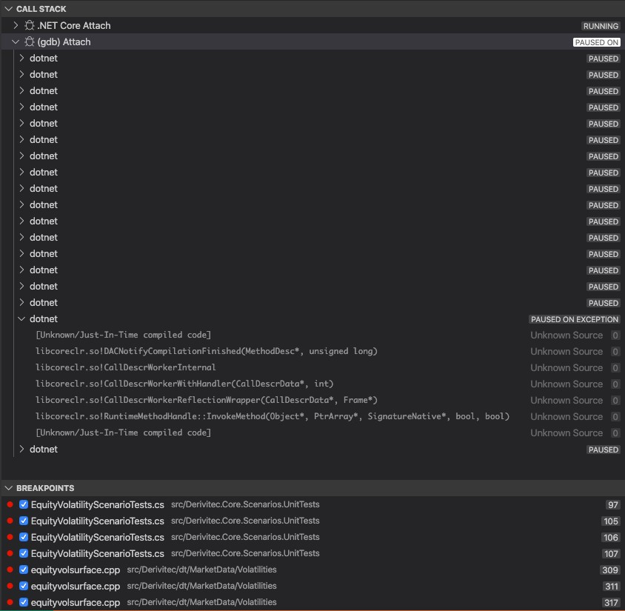

# EVALUATION

To see if Trace Diff can help students debug their code efficiently, we conducted a

controlled experiment and evaluated our interface alongside the Online Python Tutor interface.

We recruited 17 students (male: 15, female: 2; undergraduate: 13, graduate: 4) from a local

university to participate in this study. All participants major in computer science and have experience in the Python programming language. In preparation for this study, we collected a dataset of incorrect student submissions to programming problems assigned in CS1, an introductory computer science course at our university.